**Name: Basavraj Jaliminche**

**Student ID:8800149**

**Email:** [**Bjaliminche0149@conestoga.on.ca**](mailto:Bjaliminche0149@conestoga.on.ca)

**Mid Term Exam**

**Q.1.Boeing (an airplane manufacturer) had an issue with the MCAS software on their 737MAX airplane. The details can be read in the following links: https://www.usatoday.com/in-depth/graphics/2020/02/06/graphics-what-happened-and-whatsnext-boeings-737-max-8/2746204001/ https://www.nytimes.com/interactive/2019/business/boeing-737-crashes.html Based on the methodologies discussed in class, answer the following questions: 1. Briefly describe the nature of the error (including the type of error). 2. To what extent is Boeing bear morally responsible for the failure? Please recall the proper steps in evaluating moral responsibility.**

Answer-

Nature of error:

The popular 737 Max jet remains banned as authorities look into how an automatic technology on the planes contributed to the crashes, which have resulted in hundreds of deaths.

Incidents of the Boing 737 Max are:

1. 189 people were killed when Lion Air Flight 610 crashed just minutes after taking off from Jakarta, Indonesia.
2. Ethiopian Airlines Flight 302 crashed minutes after takeoff, killing all 157 passengers and crew members on board.

* According to an internal complaint, a senior engineer at Boeing said that the corporation rejected a safety system that could have decreased the risks that contributed to the two fatal crashes in order to save money.
* One of numerous variables cited in the investigations was the MAX's Maneuvering Characteristics Augmentation System, or MCAS. MCAS is an onboard flight-control system designed to compensate for the MAX's bigger engines and give pilots the same experience as earlier 737 versions.
* Boeing acted unethically in approving the plane for sale. Yes, that is my tentative answer. Boeing engineers and managers, in my opinion, may have broken ethical rules.
* A single defective sensor caused both disasters, causing a new automatic anti-stall system to continuously push the plane's nose down. Boeing charged extra for relatively simple and inexpensive warning displays in the cockpit that alert pilots about divergent sensor data, according to many newspapers. Pilots would have been more likely to detect the failing anti-stall system if similar displays had been deployed on the two 737 MAX 8s that crashed. The safety, health, and welfare of the public are not prioritized by an aircraft manufacturer who tries to boost profits by charging extra for very basic but critical safety systems.
* Pilots were never told that the new 737 MAX 8 model was equipped with an automatic anti-stall system, or that it could be activated by a single sensor reading that was incorrect. Because the pilots were unaware of the automatic anti-stall system, they were baffled as to why the onboard computers kept pushing the plane's nose down.
* SO morally the engineers and management of Boeing is responsible for this two crashes.

Reference :

1. <https://www.nytimes.com/interactive/2019/business/boeing-737-crashes.html>
2. <https://www.usatoday.com/in-depth/graphics/2020/02/06/graphics-what-happened-and-whats-next-boeings-737-max-8/2746204001/>
3. <https://blog.apaonline.org/2019/04/08/the-ethical-failures-behind-the-boeing-disasters/>

**Q.2 Based on the Confusion Matrices presented comparing the classified outcomes for RSDD and BDSA students, please calculate the three measures of fairness we discussed and practiced in class:**

**a) Predictive Parity**

**b) Disparate Impact**

**c) Error Rate Balance**

**Make sure you discuss any conclusions you draw from the calculations.**

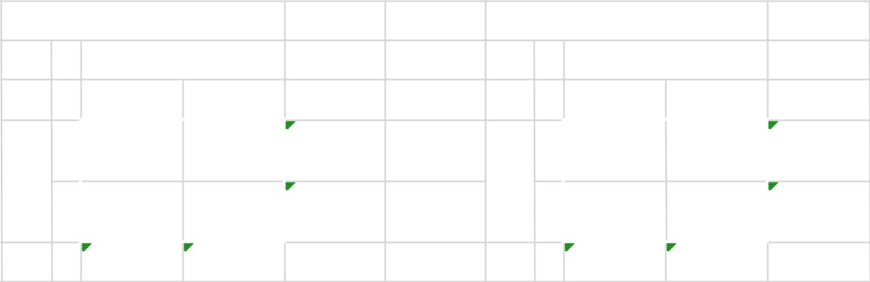

**RSDD**

**Actu**

**al**

**0**

**1**

**Students**

**Prediction**

**0**

**1**

136

38

174

44

129

173

180

167

347

**BDSA**

**A**

**ctu**

**al**

**0**

**1**

**Students**

**Prediction**

**0**

**1**

125

45

170

39

138

177

164

183

347

Answer:

The calculations are done in excel sheet and attached the screen shot on the next page.

Conclusion:

* Predictive Parity for both groups is same.
* Disparate Impact is -4% for both RSDD and BSDA that is allowed.
* Balanced error rate is (FPR=FNR) for both RSDD and BDSA is same.

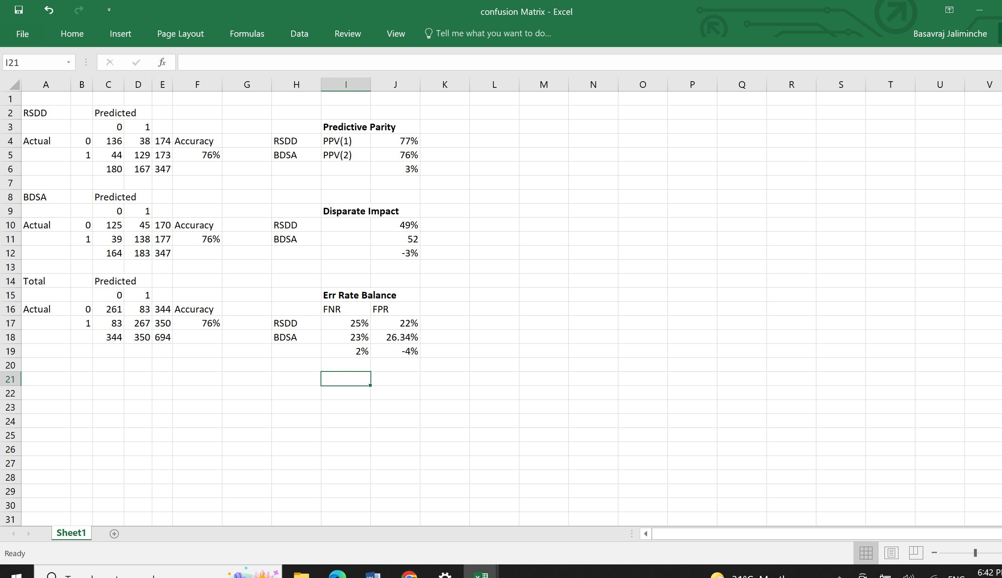

**Q.3 Consider the dataset below. Using k-anonymization and the two techniques discussed in class (generalization and suppression), create an anonymized dataset with k=2 and the QI of Postal Code, Age, and Sex. That is, names should be removed and income should not be modified. The remaining three variables should be sufficiently modified so that anonymity is preserved for k=2.**

|  |  |  |  |
| --- | --- | --- | --- |
|  |  |  | **Income**  **(In** |
| **Name** | **Postal Code** | **Age Sex** | **$,000)** |
| Lowery | N2L 7D4 | 46 F | 17 |
| Acevedo | NOB 3A0 | 52 F | 76 |
| Freeman | NOB 3A3 | 48 M | 38 |
| Mckee | NOB 3A4 | 26 M | 28 |
| Gonzales | N2L 7D6 | 39 M | 84 |
| Peterson | N2L 7D3 | 47 F | 61 |
| Avila | NOB 3A1 | 42 M | 89 |
| Shields | N2L 7D5 | 26 M | 47 |
| Gonzalez | NOB 3A2 | 45 F | 98 |
| Mcdowell | N2L 7D7 | 43 F | 37 |

Answer: -

|  |  |  |  |
| --- | --- | --- | --- |
| **Name me** | **Postal Code** | **Age** | **Sex** |
| xxx | N2L | 40s | F |
| xxx | NOB | 50s | F |
| xxx | NOB | 40s | M |
| xxx | NOB | 20s | M |
| xxx | N2L | 40s | F |
| xxx | N2L | 40s | F |
| xxx | NOB | 40s | M |
| xxx | N2L | 20s | M |
| xxx | NOB | 40s | F |
| xxx | N2L | 40s | F |

1.Name is modified and postal code is also modified, age is also modified.

2.Anonymity is preserved for k=2.